Note: This document is “view only”. Please create a copy of this document and save it to your drive.

**SOP- Internal Joint Venture/Affiliate Partners Onboarding, Setup and Management - Systems Vault**

**PREREQUISITES**

[MASTER: SOP- Managing Joint Venture/Affiliate Partners- Systems Vault](https://docs.google.com/document/u/0/d/1MbyGMJz75snwMwT8j9lDfp5OgdlKWnDvI55dQRdbkEc/edit)

[SOP- Project & Task Management- Systems Vault](https://docs.google.com/document/u/0/d/1c7REsC8MsWBBDmtKR6bpULsGVNPt-JGtC7Xwjx9xThg/edit)

[Master: Joint Venture/Affiliate Partners- Systems Vault](https://docs.google.com/spreadsheets/d/1yEJJKKJvoPbetZEajKTPc7TxggX011ywZla51H0CUs0/edit?usp=sharing)

Ontraport Partner Programs

Sarahnoked.com/wp-admin access

SN Members Area

Collateral file (this is shared to the affiliate member's area)

Link to affiliate area homepage

SN JV & Affiliate Partners

[Master: URLS (master links)- Systems Vaul](https://docs.google.com/spreadsheets/u/0/d/1mlQjpjNMlD4NJVtNFufaUVEE326vNw4TkKrwULAD43U/edit)t

[Teamwork PM](http://sarahnoked.com/teamwork)

**PURPOSE**

To ensure that our INTERNAL **Joint Ventures** (people who are promoting Sarah Noked OBM Products) are onboarded and set up effectively as well as management ongoing.

**POLICY**

**INTERNAL Joint Venture partners:**

1. **SN Products JV Partner Program**
   1. **JV Partners must sign up at** [**https://www.sarahnoked.com/affiliate-jv/**](https://www.sarahnoked.com/affiliate-jv/) **Once they sign up** [**partners@sarahnoked.com**](mailto:partners@sarahnoked.com) **is notified and a task is automatically set up in Teamwork PM - THIS IS WHAT TRIGGERS OUR TEAM TO START THE PROCESS BELOW**
   2. Our JV partners are high touch and we want them to have a first class experience with us so they happily promote our products to their people
   3. Payout is $700 on every sale to the affiliate, when JVs sign up, there is a separate task and onboarding regarding Payout Management: SOP MASTER- Payment Management- Sarah Noked OBM (Part 3)

**There is a recurring task for the Affiliate Manager to check the ‘**[SN JVs, & AFFILIATES](https://sarahnoked.teamwork.com/#projects/490225/tasks)**’ Project in Teamwork PM Daily**

**PARTY**

Online Business Manager

**PROPERTY**

Online Business Manager

**PROCESS**

**Part 1: Create and Implement INTERNAL JV Affiliate Task List in Teamwork**

**Part 1a: Issuing Joint Venture/Affiliate Custom Affiliate Codes**

**Part 1b: Creating Pretty Links from Affiliate Codes**

**Part 1c: Testing Affiliate Links**

**Part 1d: Setting up unique affiliate page or product for our JV partners (if necessary)**

**Part 2: Creating collateral and assets for INTERNAL JVs**

**Part 2a: Setting up specific promotion landing page with the JV (like a joint webinar and copy for emails/campaign)**

**Part 2b: Setting up a swipe file**

**PROCEDURES**

**Part 1: Create and Implement INTERNAL JV Affiliate Task List in Teamwork**

1. Create a task list for the JV Affiliate. (See Part 2 of [SOP- Project & Task Management- Systems Vault](https://docs.google.com/document/u/0/d/1c7REsC8MsWBBDmtKR6bpULsGVNPt-JGtC7Xwjx9xThg/edit)) The name of the task template is “SN INTERNAL Joint Venture/Affiliate Partners Onboarding, Setup and Management Tasklist [Affiliate Name] [Promotion Dates]”
2. **All task assigned accordingly, with due dates and task list names updated**

**Part 1a: Grabbing Affiliate Links for partners**

1. Often, an Internal JVs affiliate link will be sent to them automatically after signing up to be an affiliate. You can grab their affiliate links from the email that was sent to them.
   1. Go to Ontraport > search for the affiliate’s contact.
   2. Scroll down until the Contact Log section 
   3. Look for an email with message “JV Affiliate - Welcome email after sign up”



* 1. Open the email, and grab the link from there 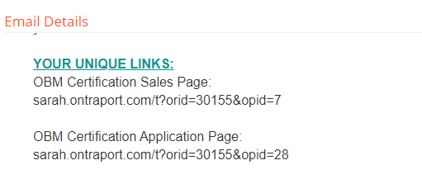

1. Go to [members.sarahnoked.com](http://members.sarahnoked.com) and login using the affiliate’s login details.
   1. Scroll down and go into Sarah Noked Affiliates. This is where JV Affiliates can find and grab their affiliate links.



* 1. Under “Your Unique Links” tab, there are 4 affiliate links: salespage, application page, Onboarding Toolkit and OBM Starter Kit
  2. Grab those and update the details accordingly in SN Master: Joint Venture/Affiliate Partners.

**Part 1b: Setting up Pretty Links**

1. Log into sarahnoked.com/wp-admin
2. From the left-hand panel from the dashboard, hover on Pretty links.
3. Add a new pretty link by clicking:
   1. Add new pretty link
   2. Add the target URL
      1. If the Target URL is an affiliate link, ALWAYS add https:// before the link. (e.g https:// + www.sarahnoked.com/cert/?orid=15778&opid=3)
   3. Follow this format sarahnoked.com/name of affiliate (example: sarahnoked.com/tina)
   4. Add a Title to the Pretty Link for identification

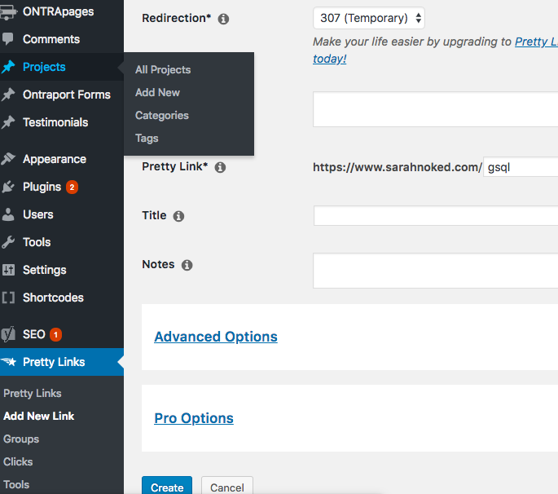

* 1. Copy the Pretty Link and update the details in SN Master: Joint Venture/Affiliate Partners

**Part 1c: Testing Affiliate Links**

1. Grab the Pretty Link you’ve just created.
2. Open Ontraport and go to Partners > Programs
3. Click on OBM Certification Partner Program ($700) then hover to Partners
4. Find the name of the JV Affiliate and take note of the current number of Visits under the JV Affiliate’s name.
5. Open an incognito tab and paste the Pretty Link you grabbed earlier.
6. Go back and refresh the the Partner Program page. Check if the number of Visits increased by 1. If not, check the Pretty Link and repeat Part 4.

**Part 1d: Setting up unique affiliate page or product for our JV partners (if necessary)**

For each affiliate program, we need all our promotional tools/links set up.

Refer to this page from OP Knowledgebase: <https://support.ontraport.com/hc/en-us/articles/217881518-Add-Partner-Promotional-Tools>

***\*note*** that when you want to get the promo link, go to the partner’s contact and change the email for now to your sn email or team@ so as to connect the account to the code

**Part 2: Creating collateral and assets for INTERNAL JVs**

This is to be discussed on a JV specific basis with Sarah

**Created by:**

**Department:** Marketing

**Date:**

**Revised:**

**Revised by:**